Role of Governance and the Efficacy of Remittances on Growth

## By: Omar King

## Introduction

The objective of this study is to expand upon the existing literature on the relationship between GDP per capita and the inflow of remittances to developing nations. Remittances are the transferred funds a migrant sends home to their country of origin via wire, mail, or online transfer. Between 2000 and 2015, the flow of worker’s remittances to developing nations dramatically increased, soaring from US$102 billion in 2000 to US $553 billion in 2015. The average annual amount a migrant remits (in 2011 constant dollars) has risen from $688 in 1990 to $2128 in 2015. However, this amount only considers those funds transferred through official channels (Azizi 2018).

A study by Clemens and McKenzie (2014) found that changes in measurement of remittances is responsible for the increase. Yet, the global development community cannot overlook the influx of financial flows sent by migrants. According to World Bank estimates, remittances far exceed the amounts of aid that flow into developing nations. Foreign aid to developing nations totaled USD $131.6 billion in 2015 in comparison to the $500 billion sent in remittance in that same year. Despite the influx of funds flowing, Clemens and McKenzie (2014) have measured the minimal effect the presence of remittances have had on GDP growth in developing economies. Ultimately, remittances do more to enrich the citizens of the receiving country, thus impacts may be too small to measure in the overall economy level. The interest of this study is to discover whether the presence of stronger governance in combination with remittances will influence GDP growth.

Furthermore, to proxy strong institutions in my model, I will be utilizing the six World Governance Indicators compiled by the World Bank. These factors include Voice and Accountability, Political Stability and Absence of Violence, Government Effectiveness, Regulatory Quality, Rule of Law, and Control of Corruption. My hypothesis is that with stronger institutions the households receiving remittances should be able to save their money and possibly see evidence of increased capital formation. However, having reviewed the literature on this topic I realize this is an optimistic viewpoint. Reason being there exists an endogeneity bias in the relationship between remittances and GDP Growth. Those countries with low GDP growth generally have larger migrant stocks, and larger migrant stocks usually lead to more remittances. To address the endogeneity issue, this research will utilize a fixed effects approach.

This paper addresses three main questions: Which of the major financial flows to developing nations has the greatest influence on GDP per capita? Assuming governance can influence growth: Which of the six World Governance indicators has the greatest impact on GDP per capita? Lastly, does increasing governance and increasing remittances lead to greater GDP per capita? The major financial flows to developing nations include remittances, foreign direct investment, capital formation, and official development aid. These factors influence economic growth, thus answering these questions will evaluate the overall effect of remittance in combination with strong governance.

## Data

This study examines 13 developing nations in Sub-Saharan Africa. The income and regional classification in this paper follow the conventions of the World Bank. The annual data has a time span of 2000–2017, and excludes 2001, as there are no governance indicators for that year. All data values in this paper are constant 2011 US dollars and come from the World Bank database. In order to compare financial flows that impact GDP growth the variables included in this study are GDP per capita, personal remittances received (% of GDP), gross capital formation (% of GDP), foreign direct investment net inflows (% of GDP), and net ODA received (% of GNI). In order to compare what governance factors influence GDP growth this study includes the six aggregate World Governance indicators. The indicators include estimations of Control of Corruption, Government Effectiveness, Political Stability and Absence of Violence, Regulatory Quality, Rule of Law, and Voice and Accountability specific to each country. The World Governance indicators are in their standard normal units, ranging from -2.5 to 2.5, with 2.5 representing the highest measure of rating per specific category. Below is table of summary statistics from my data set.

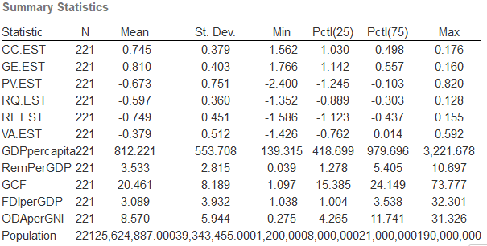

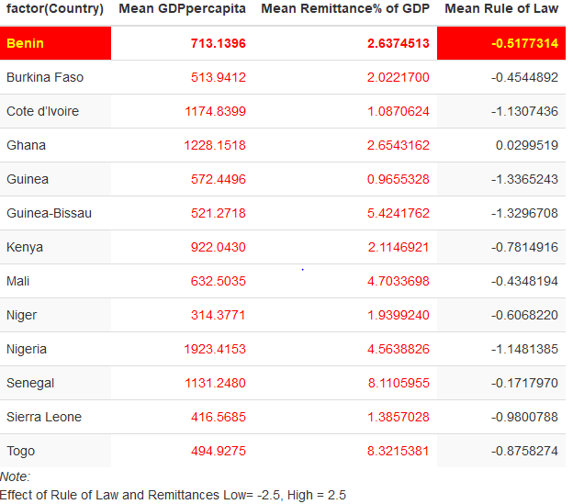

## Results and Methodology

I use the panel data method to analyze how worker’s remittances affect GDP per capita growth in 13 developing nations. In addition, I also sought to measure how the six World governance measures when interacted with Remittances would affect GDP per capita growth of these countries. As a result, I built three econometric models to measure these relationships independently and then jointly. In all three models, I utilized fixed effects method in order to control for the endogeneity bias in the relationship between remittances and GDP.

### Financial Flows to Developing Countries 2000-2017

For the following model of financial flows, I utilized the percentage share of GDP of each factor to ensure scale would not be an issue as some countries in the sample are larger than other countries in the sample. The model includes remittances, gross capital formation, total foreign direct investment, and foreign aid. The results of the model conclude that there is positive relationship between remittances as a percentage of GDP and overall GDP per capita for a country. We find that an increase in remittances, leads to around an increase of $25 dollars in GDP per capita. A surprise result from this show that there is a negative relationship between capital formation and GDP per capita growth. This is counter to my initial hypothesis that capital formation would be positive. This may be the result of increasing capital improving production for producers but ultimately reducing earning for the working class. We also find that aid negatively effects GDP per capita, which may the result of corrupt governments limiting the efficacy of well-intentioned aid.

$Y_{i,t}=β_{0 }+ β_{1}\left({Remit}_{i,t}\right)+ β_{2}\left({Capital}_{i,t}\right)+ β_{3}\left({FDI}_{i,t}\right)+ β_{1}\left({Aid}_{i,t}\right)+e_{i,t}$

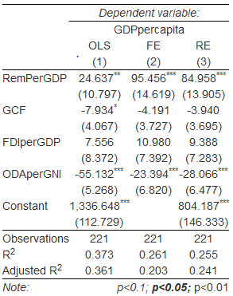

### 2. Governance Effect on GDP per Capita

Again, I used fixed effects method to analyze how world governance indicators affect GDP per capita growth. The goal was to highlight which governance indicators are most important to target to spur further growth. The results of the model conclude that the Rule of Law indicator has the greatest magnitude effect on GDP per Capita. This make intuitive sense, as when investors are confident in enforced property rights they are more likely to invest and spur growth. A surprise from this model is that increased perception of government effectiveness are associated with lower GDP per capita. This may result from some of the more autocratic regimes within the sample who tend to have lower GDP per capita.

$Y_{i,t}=β_{0 }+ β_{1}\left({Corruption}_{i,t}\right)+ β_{2}\left({GvtEffect}_{i,t}\right)+ β_{3}\left({Violence}_{i,t}\right)+ β_{4}\left({Regulations}_{i,t}\right)+ β_{5}\left({Law}_{i,t}\right) + β_{6}\left({Voice}_{i,t}\right) +e_{i,t}$

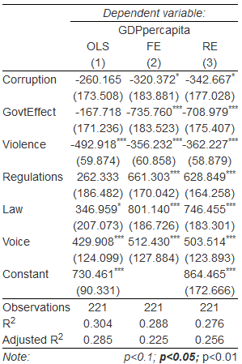

### 3. Remittance Interacted with Rule of Law

Finally, I used fixed effects method to analyze how the presence of worker’s remittances in interaction with perceptions of the rule of law in each country. I factored other financial flows like gross capital formation, total foreign direct investment, and foreign aid. The results of the model conclude that the interaction between remittances and rule of law is associated with approximate US $30 increase in GDP per capita. Though marginal, for the global poor this would make a significant difference, but may not lead to significant jumps in overall GDP growth. In the model, we also see negative statistically significant relationship between increased capital formation and foreign aid. Foreign Direct investment has a marginal, but statically significant effect on GDP per capita.

$Y_{i,t}=β_{0 }+ β_{1}\left({Remit}_{i,t}*{Law}_{i,t}\right)+ β_{2}\left({Capital}_{i,t}\right)+ β_{3}\left({FDI}_{i,t}\right)+ β_{4}\left({AID}_{i,t}\right)+e_{i,t}$

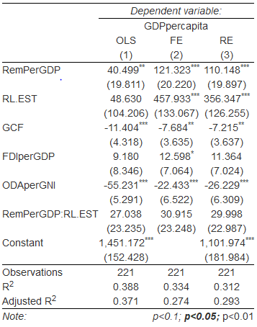

## Conclusion

Remittances in combination with Rule of Law can increase GDP per capita. We find that of all the major financial flow to developing nations, remittances have the greatest statistically significant impact on GDP per capita. In addition, among all the World Governance indicators, Rule of Law has the greatest statistically significant impact on GDP per capita. The impact is especially important since Rule of Law is leading indicator in the promotion of growth in well-functioning societies.

All the data in my dataset originates from The World Bank. I have pulled information for the following thirteen countries: Benin, Burkina Faso, Cote d'Ivoire, Ghana, Guinea, Guinea-Bissau, Kenya, Mali, Niger, Nigeria, Senegal, Sierra Leone, and Togo. The timeline of this study is from 2000 – 2017, excluding the year 2001, as there is no governance indicators available for that year. I have 222 observations in total. Developing governments can use the results of this research as reasoning to improve Rule of Law, because in doing so they increase the maximization of the inflow remittances to spur economic growth.

## References

1. Docquier, Frédéric, and Hillel Rapoport. 2012. "Globalization, Brain Drain, and Development." *Journal of Economic Literature*, 50 (3): 681-730.
2. Plaza, Sonia, Mario Navarrete, and Dilip Ratha, 2011. Migration and Remittances Household Surveys: Methodological Issues and New Findings from Sub-Saharan Africa [PDF, 1.3 MB], 2011. Washington, D.C.: World Bank. (Africa Migration Project, Migration and Remittances Unit, World Bank).
3. Clemens, Michael Andrew and McKenzie, David John, Why Don't Remittances Appear to Affect Growth? (May 1, 2014). World Bank Policy Research Working Paper No. 6856. Available at SSRN: <https://ssrn.com/abstract=2433809>
4. Azizi, SeyedSoroosh. “The Impacts of Workers' Remittances on Human Capital and Labor Supply in Developing Countries.” Economic Modelling, North-Holland, 25 July 2018, [www.sciencedirect.com/science/article/pii/S0264999318302542](http://www.sciencedirect.com/science/article/pii/S0264999318302542).

## 6. Appendix

